**PROJECT NO 3**

**Snapshots**

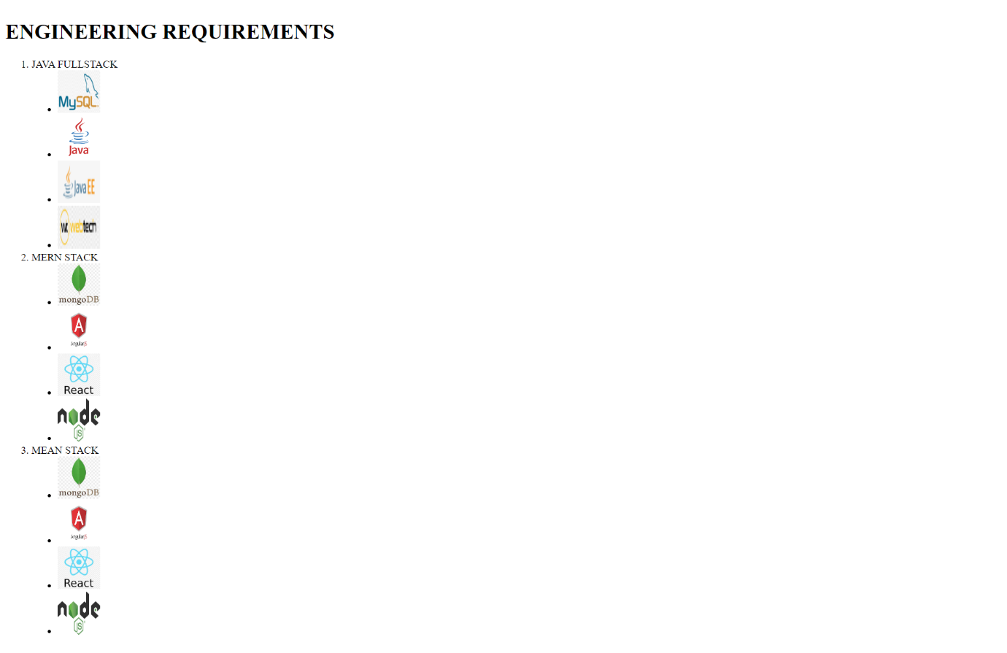

**Code:-**

